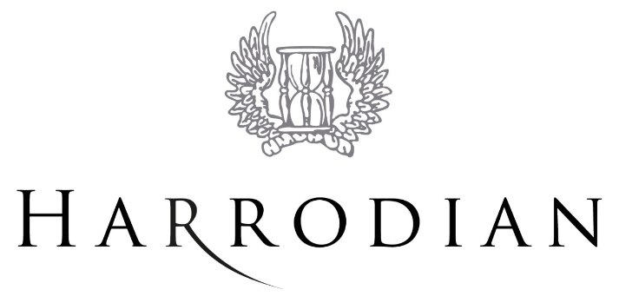

EEF POLICY

INTRODUCTION
This policy is written, and EEF delivered, within statutory and local authority guidelines which may be updated from time to time.

The government gives local authorities funding to provide part time early education for all two, three and four year olds. The Harrodian is an eligible setting for providing Early Years Education. This entitles parents of our pupils to claim early years education funding.

EEF Eligibility
3 and 4 year old funding
This is a universal funding which provides up to 570 hours of free childcare a year effective from the term following the child’s 3rd birthday, this is normally delivered for 15 hours a week over 38 weeks a year. For Harrodian pupils this will be 33 weeks matching the weeks of the school year. Funding is claimed by and paid directly to the provider from the local authority in which they are based.

2 year old funding
This is an eligibility based funding for up to 570 hours of free childcare a year effective from the term following the child’s 2nd birthday. Applications for 2 year old funding are made via the local authority and places can only be allocated once eligibility has been confirmed. Eligibility is confirmed by the local authority that the provider is based within and then claimed and paid directly to the provider.

We do not offer 2 year old funded places.

Further information on early years funding can be accessed via your local authority website: www.richmond.gov.uk

Delivery and Charges
As the hourly amount will change from year to year so will the amount parents are able to claim. The hour is multiplied by 15 hours per week which is multiplied by the amount of weeks in the term for example;

£3.62 per hour for 15 hours per week provision for each of the 11 weeks of the term.

Hence £3.62 x 15 x 11 = £597.30

The funding can be claimed up to 33 weeks per pupil dependent on their birthday and when they started at Harrodian School.

The funding will continue for the Spring Term for those pupils who are still four years of age on 31st December 2016 and for the Summer Term for those pupils who are still four on 31st March. The number of terms’ funding therefore depends upon your child’s birthday.

The school will be applying for this funding on your behalf and all we need from you is the completed Parent Declaration Form (enclosed). The funding, once approved, is received directly by the school towards the end of each term and will be credited against your fee account two terms forward.

Please note that this funding is entirely optional.
Parental Declaration
To claim for EEF, parents must complete a Parent Declaration Form. These will handed out to parents via the class teacher of eligible children, along with a letter explaining what EEF is and how to fill in the forms. A deadline for completing and returning these forms will be outlined in the letter.
Any forms received beyond that date will be unable to be processed (without exception).

Queries and Complaints
Should parents have any queries or concerns, Caroline Parker (cparker@harrodian.com) will assist. Any issues not resolved can be taken to the Achieving for Children Early Years Team at
early.years@achievingforchildren.org.uk

Person responsible: C Parker Last update: September 2016
Next update: September 2017

