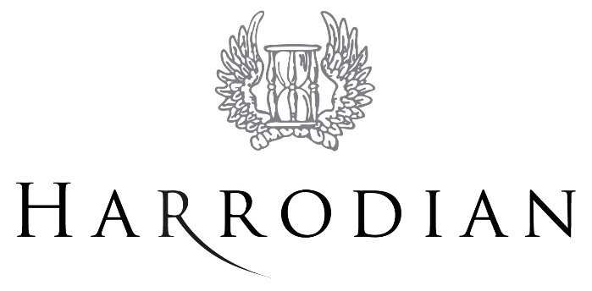
Reviews of Marking Policy – Centre Assessed Marks
(GCSE controlled assessments, GCE coursework, GCE and GCSE non-examination assessments)

Harrodian is committed to ensuring that whenever its staff mark candidates’ work this is done fairly, consistently and in accordance with the awarding body’s specification and subject-specific associated documents.
Candidates’ work will be marked by staff who have appropriate knowledge, understanding and skill, and who have been trained in this activity. Harrodian is committed to ensuring that work produced by candidates is authenticated in line with the requirements of the awarding body. Where a number of subject teachers are involved in marking candidates’ work, internal moderation and standardisation will ensure consistency of marking.
- Harrodian will ensure that candidates are informed of their centre assessed marks (not grade/overall grade) so that they may request a review of the centre’s marking before marks are submitted to the awarding body.

- Harrodian will inform candidates that they may request copies of materials to assist them in considering whether to request a review of the centre’s marking of the assessment.

- Harrodian will, having received a request for copies of materials, promptly make them available to the candidate.

- Harrodian will provide candidates with sufficient time in order to allow them to review copies of materials and reach a decision.

- Requests for reviews of marking must be made in writing using the Harrodian Candidate Request for Review of Marking and Consent Form.

- Harrodian will allow sufficient time for the review to be carried out, to make any necessary changes to marks and to inform the candidate of the outcome, all before the awarding body’s deadline.

- Harrodian will ensure that the review of marking is carried out by an assessor who has appropriate competence, has had no previous involvement in the assessment of that candidate and has no personal interest in the review.

- Harrodian will instruct the reviewer to ensure that the candidate’s mark is consistent with the standard set by the centre. A reviewed mark may go down as well as up.

- The candidate will be informed in writing of the outcome of the review of the centre’s marking.

- The outcome of the review of the centre’s marking will be made known to the Head of Centre and will be logged as a complaint. A written record will be kept and made available to the awarding body upon request. Should the review of the centre’s marking bring any irregularity in procedures to light, the awarding body will be informed immediately.
After the candidates’ work has been internally assessed, it is moderated by the awarding body to ensure consistency in marking between centres. The moderation process may lead to mark changes. This process is outside the control of Harrodian and is not covered by this procedure.

Person responsible: Deputy Headmistress Last update: January 2018
Next update: September 2018

