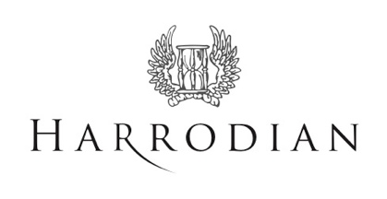

Harrodian School Bus Service

Notting Hill and Kensington

The Harrodian School currently provides a morning bus service for the collection of children in the W2, W8, W11 and W14 areas at a cost of £15.00 per child, per morning. This service has been running successfully for many years and ensures that our children arrive at school in time for morning registration.
We endeavor to collect children from their home address where possible, however if this is unviable, then we will suggest an alternative convenient location.
Please note that there are a limited number of places available on the buses.
If you are interested in booking a place for your child/children in the Autumn term or if you have any queries, please do not hesitate to contact Barry Craddock, Transport Manager at: transport@harrodian.com

Harrodian School Coach Service

Hammersmith and Chiswick / Kensington and Fulham

The Harrodian also works with Westbus to provide a dedicated coach service, available to all ages, with two routes available: Hammersmith and Chiswick plus Kensington and Fulham.

Hammersmith and Chiswick
Routes / stops are as follows:
Morning: Hammersmith Bridge Road, King Street / Goldhawk Road, Bath Road / Arts Ed / Turnham Green, Heathfield Terrace Post Office and onto Barnes.
Arrival at school - 8.20am/25am
Afternoon: Departure from school - 4.20pm, Staveley Road, Hammersmith Bridge Road,
King Street/ Goldhawk Road, Bath Road / Arts Ed / Turnham Green and Heathfield Terrace Post Office.

Kensington and Fulham
Routes / stops are as follows:
Morning: Kensington High Street, Fulham Road/ Parsons Green lane, Fulham High Street.
Arrival at school - 8.20am
Afternoon: School departure - 4.20pm, Fulham High Street, Fulham Road / Fulham Library and
High Street Kensington.

The cost is £10 per child per day, payable a term in advance.
A booking form will be sent to parents who would like to use the service, starting in September.
To request a booking form, please email transport@harrodian.com, for the attention of Rachael Snaith.
Please send all correspondence by Friday 18 June 2021.

